Smart Mining Special Program Participant Application Requirements

**1. Program Overview/Propose**

This program is intended for Master course students and aims to train global talents who have practical "future" resource development studies (Smart Mining) absorbing informatics (AI, IoT, big data, etc.) proactively in Japan and Southern African countries, based on "conventional" resource development studies.

To accomplish this, this program offers a curriculum which fosters talents who can manage mineral resources, environment, economics, and social system from creative and panoramic perspectives by utilizing technology and knowledge of informatics based on practical skills backed by advanced expertise in resource sciences. Under the collaboration of Akita University and Kyushu University, students will attend lectures in partnership with students from five universities in four Southern African countries and visit each other in Africa and Japan for training and research.

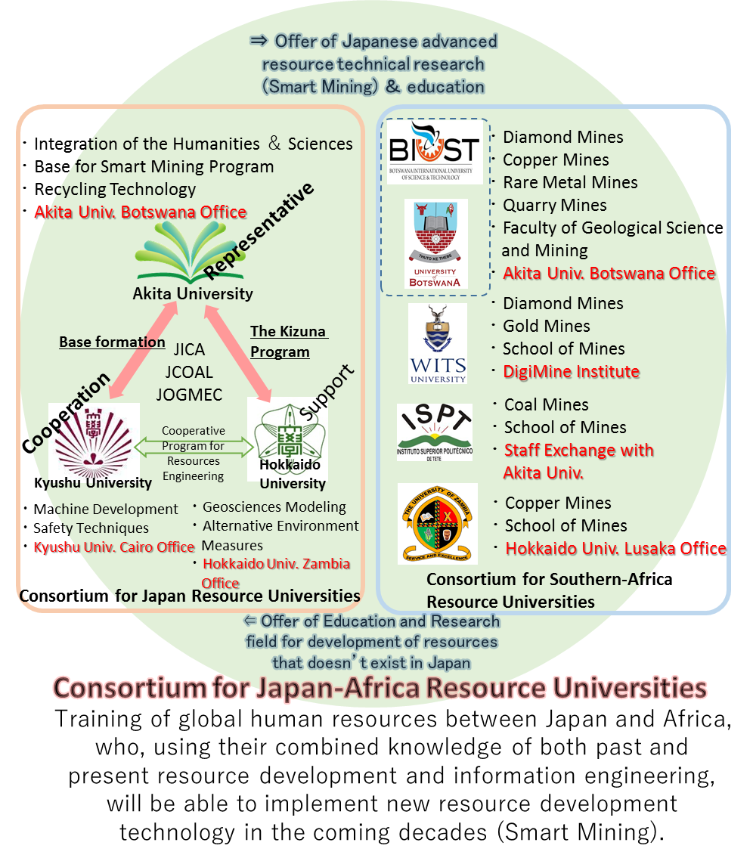



**2. Development of Global Leaders**

1. Practical skills based on advanced technical knowledge.
2. Ingenious technological development skills based on a solid foundation of information engineering allow for a dimensional transition into the next stage of current resource development studies.
3. Design and management capabilities with a panoramic view of the whole resource and environmental system.
4. The ability to negotiate between producer and consumer with a firm understanding of the position of both parties. The goal is to foster global talent with a sense of balance in all aspects.

In other words, the program fosters global talents who can design the entire resource industry system based on environmental response, economic rationality, and international relations while utilizing information engineering.

**3. Curriculum**

Students enrolled in the Smart Mining Special Program will attend the following lectures: All courses will be completed in English, and a program certification will be issued to students who have completed the credits. The credits for the lectures in this special program will be included in the requirements for completion of the master’s course. However, the Collaborative Training 2 and the Collaborative Research Project, which involve overseas travel, may be held online depending on the situation of COVID-19.

① Virtual Online Traveling Class (M1) 2 credit

In order to enhance the level of basic knowledge in resource development studies, participants will virtually attend introductory lectures on resource development and smart mining online from experts at Akita University, Kyushu University, and Hokkaido University. JICA will also provide an Introduction to Development Studies.

② Collaborative Training 1 (M1) 1 credit

Students will take online courses in the social sciences related to resource development, such as resource economics, international relations, development studies, and energy systems, and will engage in discussion exercises based on these courses. This course plays a role in comprehensive education for sustainable resource development in Africa and provides subsequent research and development guidelines.

1. Basics of Mining Informatics (M1) 1 credit

Using GOOCUS, an online learning management system (LMS, Learning Management System), all participating students from Japan and Africa will learn the basics of resource informatics. This program provides practical information engineering education for resource students, which is the core of this program.

④Japanese/English Language Training (M1~M2) 1 credit

To improve communicative language skills, we provide on-demand e-learning of languages through GOOCUS (Learning Management System). Students whose mother tongue is Japanese will be provided with the opportunity to learn English, while students from other countries will be provided with the opportunity to learn Japanese.

⑤ Collaborative Training 2 (M2) 2 credits

We will visit the DigiMine Lab. at the University of Witwatersrand, which leads the way in smart mining in South Africa, learning about the latest smart mining technologies, and experiencing hands-on tutorials using teaching materials (approximately ten days). The course provides the best opportunity to give a concrete vision of the knowledge gained in "Basics of Mining Informatics."

⑥ Collaborative Research Project (M2) 4 credits

All students from Japan and Africa will gather at Akita University to conduct special team research related to smart mining, organized by the Consortium of Japan-Africa Resource Universities at the Akita University International Center for Research and Education on Mineral and Energy Resources (approximately two weeks). The teams will be a mixture of Japanese and African students to deepen exchanges, share their awareness of each other's problems, and develop problem-solving skills.

**3. “Smart Mining Special Program” Certificate**

Graduate students who participate in the program will receive a master’s degree from their own institution and certificate of program completion.

**4. Program Participating Time Period**

First two years of Master’s course

**5. Number of applicant**

5 students each from Akita University and Kyushu University

2 students from each African University

**6. Eligibility for application**

Students who fully understand the purpose of this program and are currently or will be enrolled in the master's program of Akita University or Kyushu University.

**7. Application format**

〈Application Period〉

Application period: February 14th (Tue), 2023~ February 22nd (Wed), 2023

〈Application form〉

1. Application

Fill out the application

1. Research Plan

For the theme or field in which you wish to conduct your research, describe the purpose and concept of your research in about 1000 Japanese characters (300 words for English) on the appointed form after consulting with your research supervisor.

1. Motivation for participating in this program

About 600 Japanese characters (about 200 words in English).

1. Transcript of the last school you have attended

Transcript of the last school attended (in Japanese or English)

1. Documents related to English ability

Copy of transcript of TOEIC, TOEFL, IELTS, EIKEN, etc., or explanation of overseas stay or work experience using English, etc.

〈Where to send〉

Please compile the above documents into a ZIP file and send it by e-mail to the following address.

Akita University Inter-University Exchange Project Office: [tenkairyoku@gipc.akita-u.ac.jp](mailto:tenkairyoku@gipc.akita-u.ac.jp)

The subject of the e-mail should be as follows, with your name in parentheses at the end.

[Application documents in process] Smart Mining Special Program (your name)

**8. Selection Process**

Applicants will be interviewed based on the submitted application documents. The results of the interview and the application documents will be used to make a final decision. Please follow the details of the interview date, time, and venue as they will be provided directly by the office.

**9. Assistance with Travel Expenses**

Travel expenses to South Africa for the Collaborative Training 2 and travel expenses for Kyushu University students to Akita University will be covered by this program. However, overseas travel insurance is the responsibility of the participant.

Dual use of “Scholarship” provided by the Japan Student Service Organization (JASSO) and “Public-Private Joint Support Tobitate! (Leap for Tomorrow) Study Abroad Initiative” will not be acceptable for subsidies for travel expenses.

**11. Inquiries**

Room N207, 2nd floor, Building 1, Faculty of International Resource Sciences, Akita University

Inter-University Exchange Project Office

TEL: 018-889-2496

EMAIL: [tenkairyoku@gipc.akita-u.ac.jp](mailto:tenkairyoku@gipc.akita-u.ac.jp)